SUBSTITUTION
Pearson Edexcel - Thursday 4 June 2020 - Paper 2 (Calculator) Foundation Tier

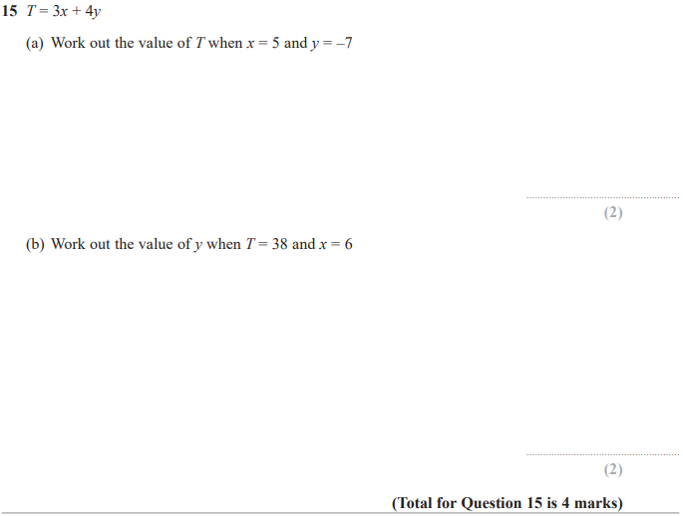

Pearson Edexcel - Thursday 6 June 2019 - Paper 2 (Calculator) Foundation Tier

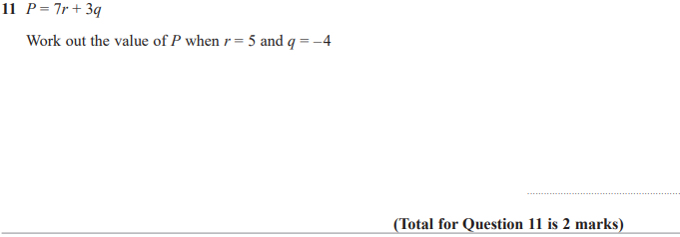
Pearson Edexcel - Tuesday 6 November 2018 - Paper 1 (Non-Calculator) Foundation Tier

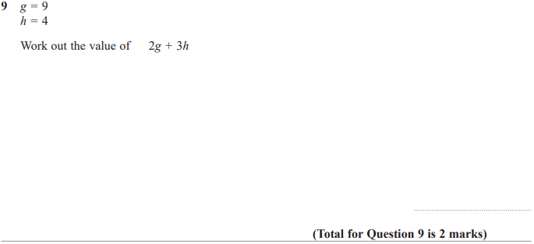

Pearson Edexcel - Thursday 24 May 2018 - Paper 1 (Non-Calculator) Foundation Tier

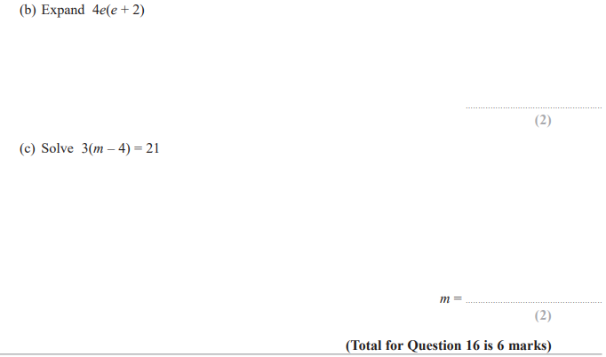

Pearson Edexcel – Specimen 2 - Paper 1 (Non-Calculator) Foundation Tier

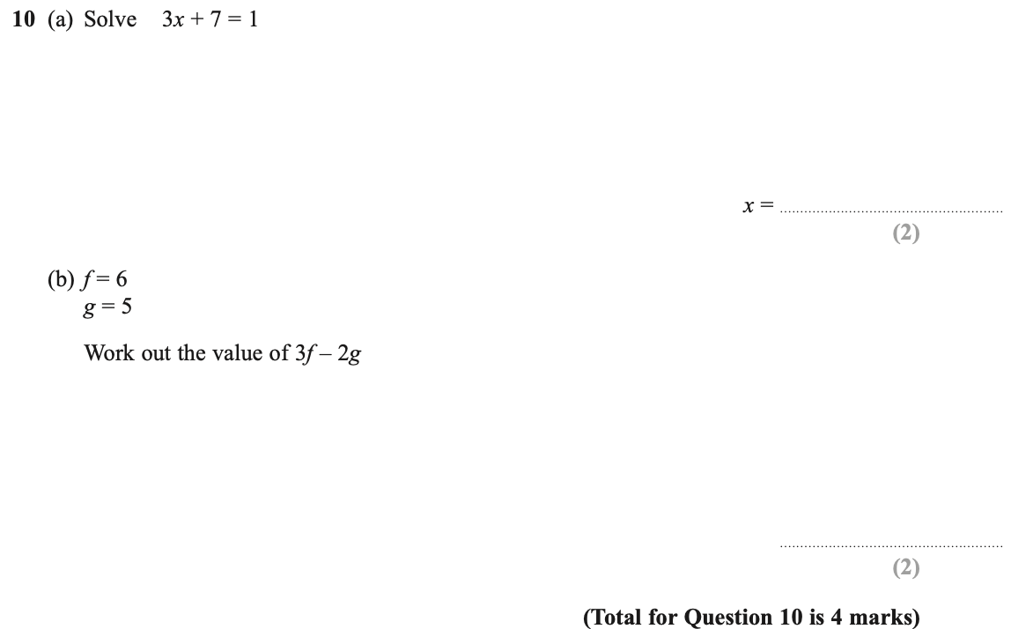
Pearson Edexcel – Specimen 2 - Paper 3 (Calculator) Foundation Tier

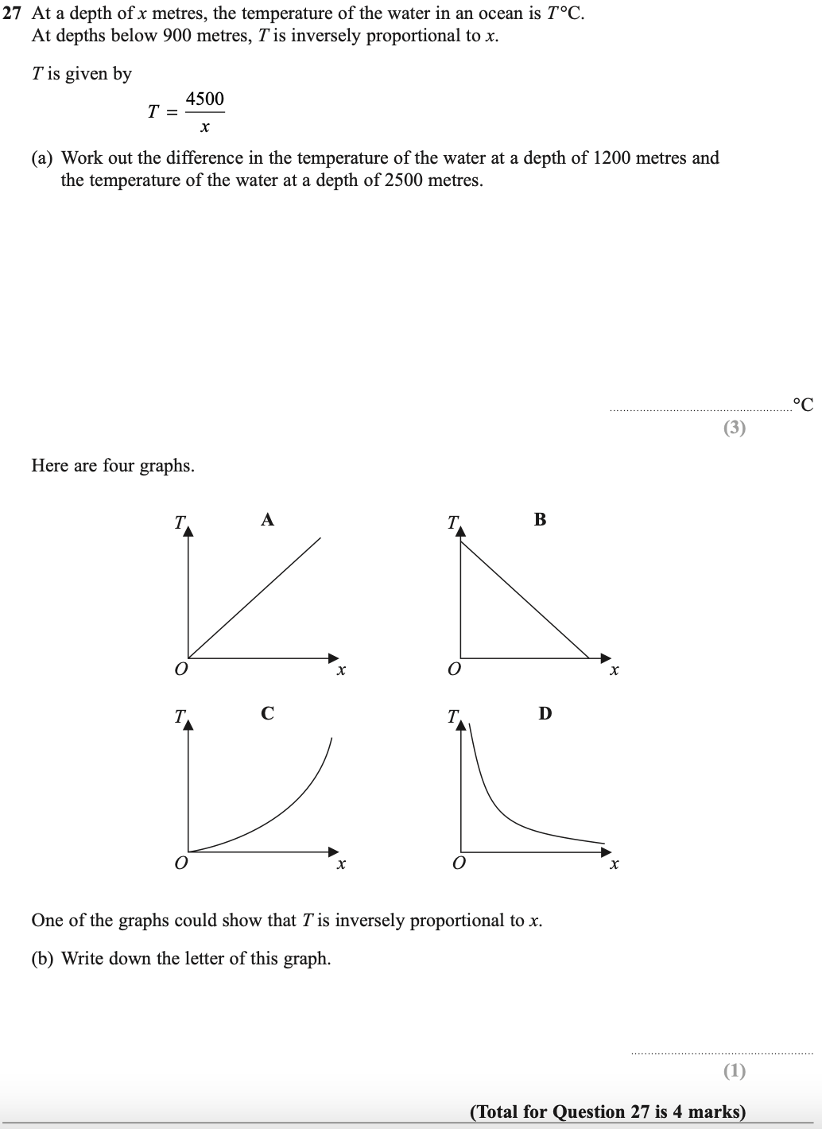
Pearson Edexcel – Specimen 1 - Paper 3 (Calculator) Foundation Tier

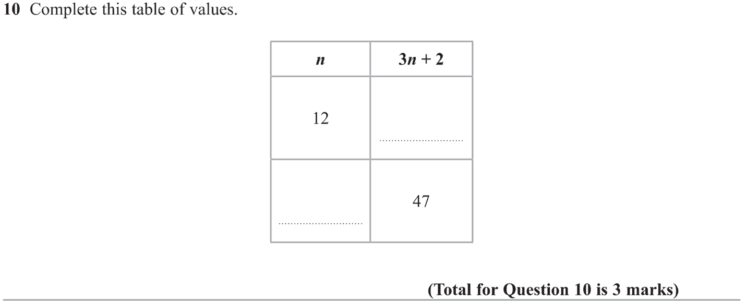

OCR Thursday 7 June 2018 – Morning (Non-Calculator) Foundation Tier
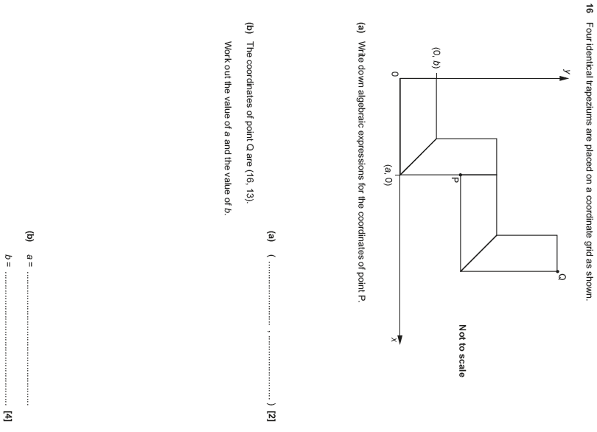

OCR Tuesday 12 June 2018– Morning (Calculator) Foundation Tier
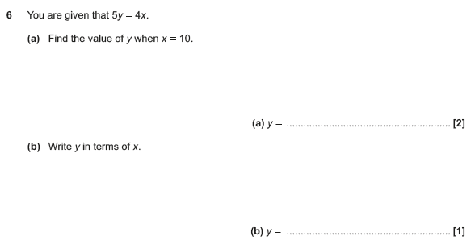

OCR Thursday 2 November 2017– Morning (Calculator) Foundation Tier
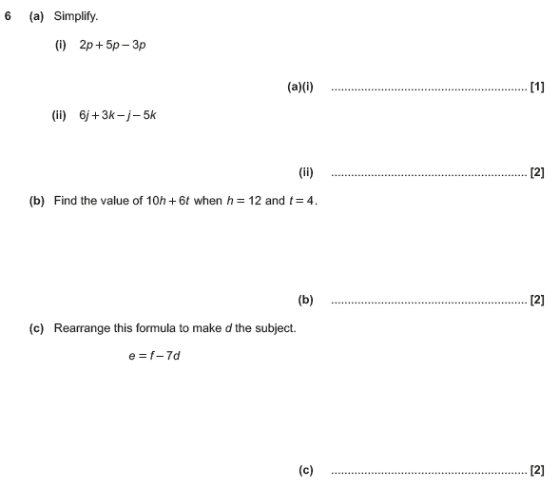

Pearson Edexcel –Sample Papers - Paper 2 (Calculator) Foundation Tier

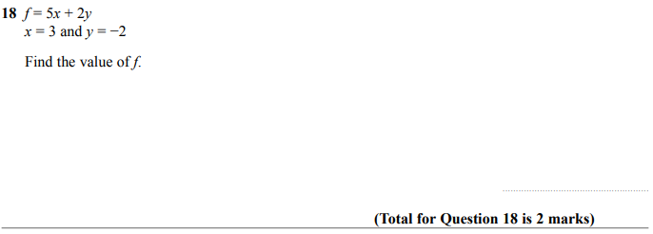

OCR Tuesday 13 June 2017 – Morning (Calculator) Foundation Tier

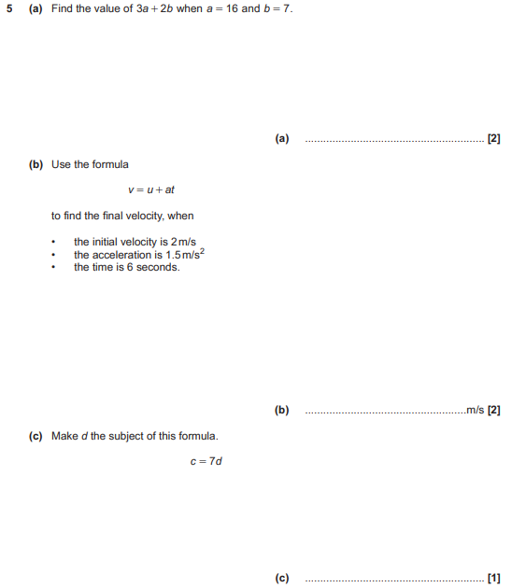

OCR Sample Question Paper 1 – Morning/Afternoon (Calculator) Foundation Tier

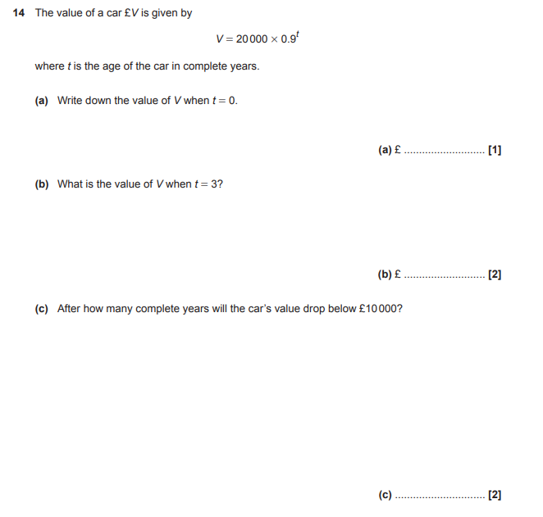

AQA Thursday 4 June 2020 – Morning (Calculator) Foundation Tier

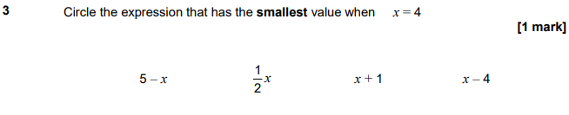
AQA Thursday 11 June 2019 – Morning (Calculator) Foundation Tier

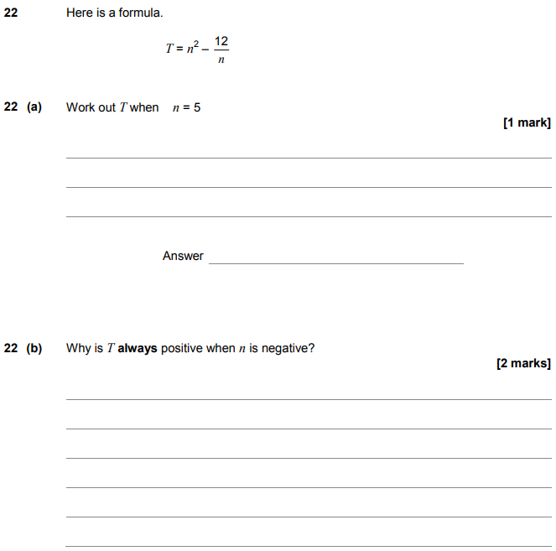

AQA Tuesday 6 November 2018 – Morning (Non-Calculator) Foundation Tier

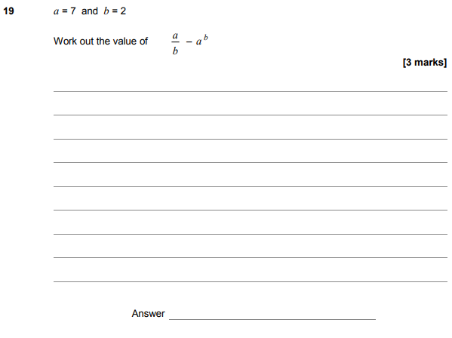

AQA Thursday 7 June 2018 – Morning (Calculator) Foundation Tier

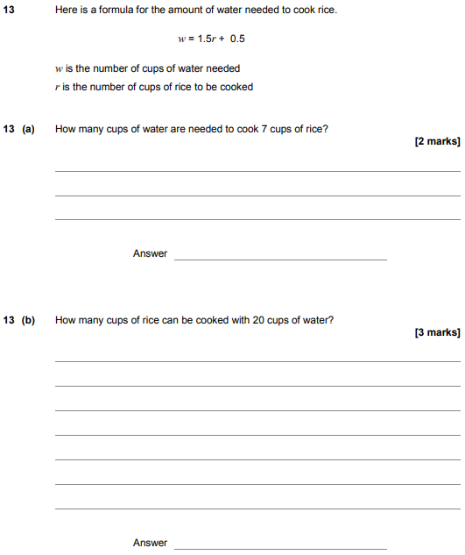

AQA Thursday 25 May 2017– Morning (Non-Calculator) Foundation Tier

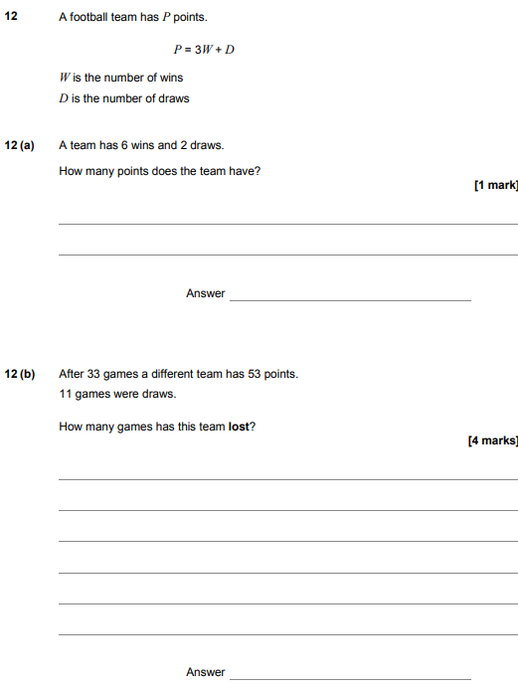\

AQA Tuesday 13 June 2017 Morning– Morning (Calculator) Foundation Tier

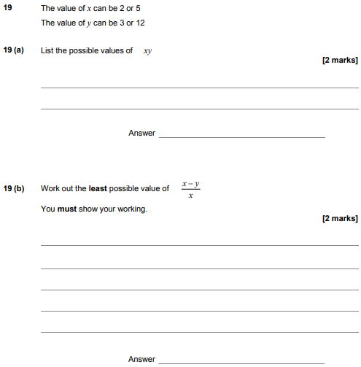

AQA Sample Paper 1– Morning (Non-Calculator) Foundation Tier

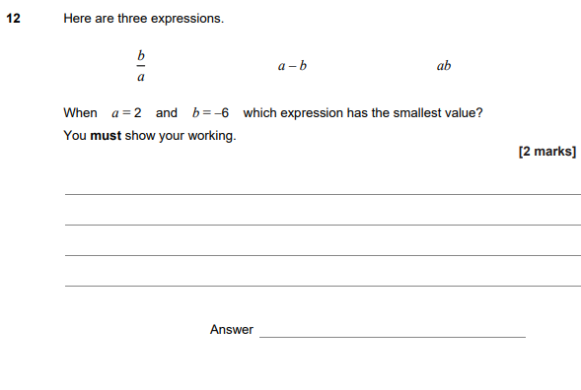

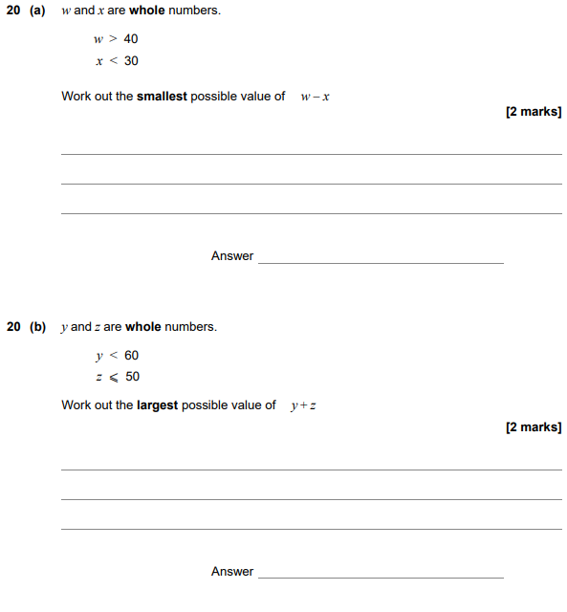

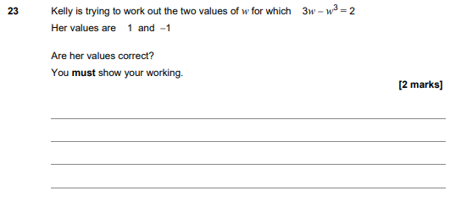

AQA Sample Paper 2– Morning (Calculator) Foundation Tier

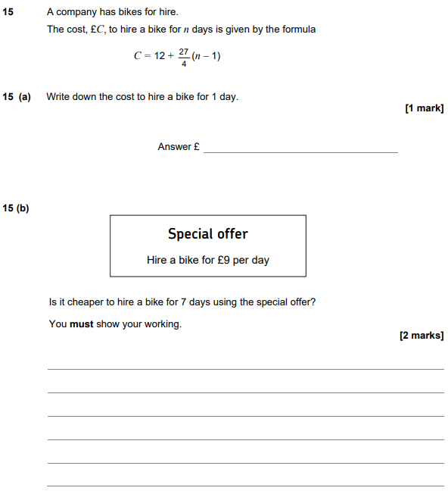
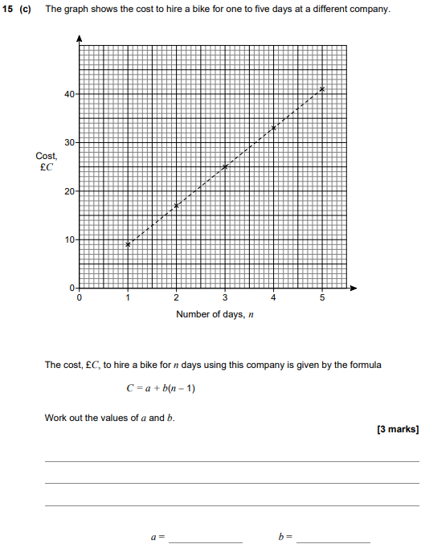

AQA Sample Paper 3– Morning (Calculator) Foundation Tier

